WALK WITH A SCHOLAR (WWS) 2018 – 2019
ST. ALOYSIUS COLLEGE, EDATHUA.
ANNUAL REPORT

Walk With a Scholar (WWS) is a new initiative of the Department of Collegiate Education, Government of Kerala with an aim to support a student in his/her developmental aspects such as cognitive, mental, emotional, behavioral, and social for bringing out a best citizen. The concept of ‘mentoring’ is the key idea behind the WWS.
Mentoring is a cosmopolitan concept for helping an individual for achieving his maximum potential. In mentoring, the person who is helping another person is called as the mentor and the person who is being helped as the mentee. Mentor is a friend, guide and philosopher to the mentee. The various life experience and academic knowledge of the mentor enables him to transform an average person to the best. In educational system, mentoring helps a student to develop various life skills and also for identify his/her future career.
This year, WWS has two batches,1 year (2018-2019), and 2nd year (2017-2018) . Each batch is with 30 students, so a total of 60 students were participated in this programme during the year 2018-2019.
Faculty in Charge
- Mr. Jaimin George, Assistant Professor in Chemistry (Coordinator)

LIST OF INTERNAL MENTORS
SL.No | Name | Designation | Contact Number | Email id
1 | Prof.Rani George | Assistant.Prrofessor | 8129352849 | ranigeorge77@gmail.com
2 | Prof.Rosmin John | Assistant.Prrofessor | 9747347140 | rosminkattoor@gmail.com
3 | Prof.Paul Jacob | Assistant.Prrofessor | 9495164323 | pauljacobsac@gmail.com
4 | Dr.Sandy Joseph | Assistant.Prrofessor | 9447120285 | drsantyjoseph@gmail.com,
5 | Prof.Deena c Scaria | Assistant.Prrofessor | 9447018901 | deenacscaria@yahoo.co.in
6 | Prof.Gem Cherian | Assistant.Prrofessor | 9446004390 | gemcherian@live.in
7 | Prof.Praveen Joseph | Assistant.Prrofessor | 8086151935 | praveen.marattukalam@gmail.com
8 | Prof.Stephy KJ | Assistant.Prrofessor | 944624146 | stefyjk06@gmail.com
9 | Prof.Jijo Joy | Assistant.Prrofessor | 9961581502 | jijo.stcpala@gmail.com
10 | Sri.Lipson Lonappan | Guest Lecturer | 9447427846 | lipsonlonappan@gmail.com

External Mentors_(Classes 1-10)
- Prof. Saneeh P.V ,Deputy Director,MACFAST, Thiruvalla.
- Prof. Joeph A J ,HOD,Department of Englih,Naipunya College Cherthala
- Prof. Saneeh P.V ,Deputy Director,MACFAST, Thiruvalla.
- Dominic AV ,BC Cochin Corporation
- D,r. Siby k S,Assistant Prof.Department of Physics, Kerala Univerity.
- Madhu Mohan ,Trainer,M2N Inpspiration,Kodimatha,Kottayam.
- Abraham Stephen,Director,C Academy for excellence,Kottayam
- Madhu Mohan ,Trainer,M2N Inpspiration,Kodimatha,Kottayam.
- Prof. Joeph A J ,HOD,Department of Englih,Naipunya College Cherthala
- Cijo P Jacob,Trainer, Synergy HR Solutions,Cochin

Mock Interview and Gropup Discuion_(Classes 1-2 )
- Prof. Saneeh P.V ,Deputy Director,MACFAST, Thiruvalla.
- Abraham Stephen,Director,C Academy for excellence,Kottayam
Induction Programme for internal mentors
An Induction programme was held for the internal mentor on 15-10-2018.A hand book on internal mentoring was distributed.
Introduction about WWS
An induction programme about WWS was also organized for all the mentees.Dr. Shibu George,Former Co-ordinator ,WWS lead the induction programme for the mentees.
Internal Mentoring:
All the 10 internal mentors took at least 10 hours of mentoring sessions to their mentees on their convenient time. Attendance of the students was recorded. All the mentors tried their level best for motivating the students. After completing the internal mentoring sessions, they submitted a report on their activities to the coordinator.

EXTERNAL MENTORING
1. Prof. Saneeh P.V ,Deputy Director,MACFAST, Thiruvalla was the resource person for the 1st external mentoring session( SECOND YEAR) . He gave an orientation to students on the topic ‘GOAL SETTING” on 30-10-2018
2. 2nd external mentoring session was lead by Prof. Joeph A J ,HOD,Department of Englih,Naipunya College Cherthala 10-01-2019 from 10.00 am to 4.00 pm (FIRST YEAR). He gave an outlook to students on ‘Motivation and Personality’.
- Prof. Saneeh P.V ,Deputy Director,MACFAST, Thiruvalla was the resource person for the third external mentoring session for the first year. He gave an orientation to students on the topic ‘Goal setting” on 14-01-2019
- Fourth external mentoring session was lead by Dominic AV ,BC Cochin Corporation on 16-01-2019 from 10.00 am to 4.00 pm(FIRST YEAR). He gave an outlook to students on ‘Learning Skill”
- Dr. Siby k S,Assistant Prof.Department of Physics, Kerala Univerity was the resource person for the fifth external mentoring session( first year.) He gave an orientation to students on the topic ‘LEARNING SCIENCE,A HUMAN TRAIT ” on 18-01-2019
- Madhu Mohan ,Trainer,M2N Inpspiration,Kodimatha,Kottayam was the resource person for the sixth external mentoring session for the (first year). He gave an orientation to students on the topic ‘LIFE SKILLS” on 23-01-2019
- Abraham Stephen,Director,SCS Academy for excellence,Kottayam was the resource person for the seventh external mentoring session (first year). He gave an orientation to students on the topic ‘COMMUNICATION” on 25-01-2019
- Madhu Mohan ,Trainer,M2N Inpspiration,Kodimatha,Kottayam was the resource person for the eighth external mentoring session (SECOND YEAR). He gave an orientation to students on the topic ‘Goal setting” on 30-1-2019
- Prof. Joeph A J ,HOD,Department of Englih,Naipunya College Cherthala was the resource person for the ninth external mentoring session (.SECOND YEAR) He gave an orientation to students on the topic ‘COMMUNICATION AND CONCENTRATION” on 5-2-2019
- CIJO P JACOB ,Trainer,M2N SYNERGY HR SOLUTION COCHIN was the resource person for the eighth external mentoring session(SECOND YEAR). He gave an orientation to students on the topic ‘PROBLEM SOLVING” on 8-2-2019

CONDUCT OF MOCK TESTS AND GROUP DISCUSIONS
To equip our third year students for appearing public examinations such as PSC, UPSC etc, mock tests and group discussion were conducted. Prof. Saneeh P.V ,Deputy Director,MACFAST, Thiruvalla(8-2-2019) and Abraham Stephen,Director,SCS Academy for excellence,Kottayam(22-2-2019) were the resource persons.

STUDY MATERIALS
To win PSC or Civil Service or other UPSC examinations, General knowledge is inevitable. Therefore, to help our students to appear for Civil Service Examinations, 99 different text books (consisting of General knowledge, Civil Service Exam based books, PSC and UPSC exams based books, Interview tips, Personality Development,literature,culture, etc) were purchased and kept in the library for the exclusive use of WWS students. Provisions are made only for WWS student to use these books at any time.

I take this opportunity to thank the Department of Higher Education, Govt. of Kerala for providing financial support for organizing the WWS programme during the academic year 2018-2019. I acknowledge the co operations and supports given by the Principal, External and Internal mentors, for the smooth functioning of the WWS programme.

21th MARCH 2019 Jaimin George
Coordinator, WWS

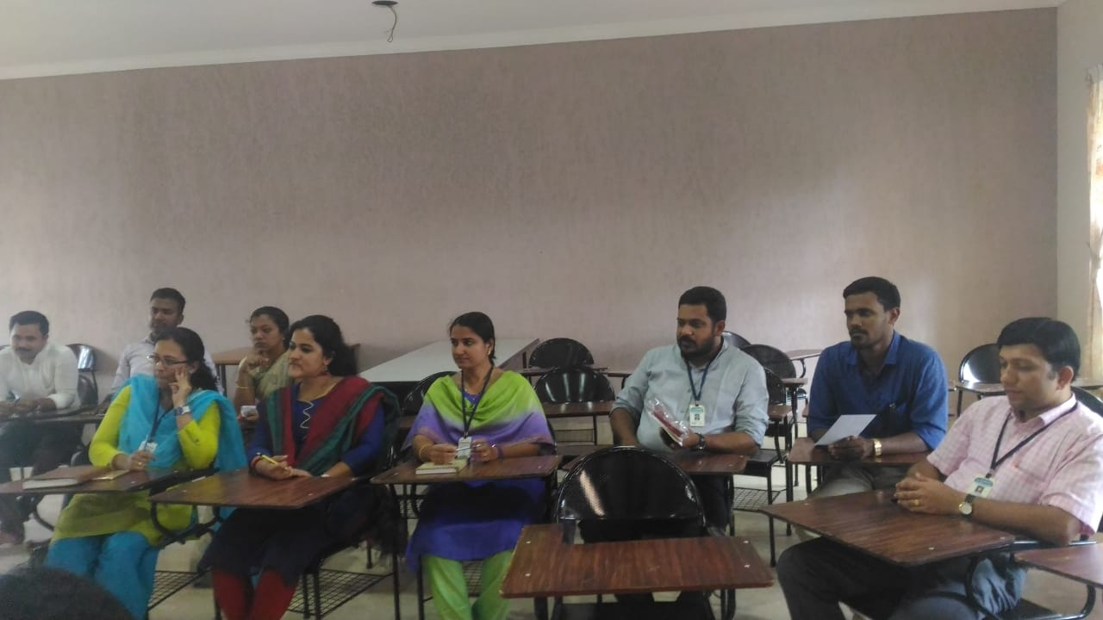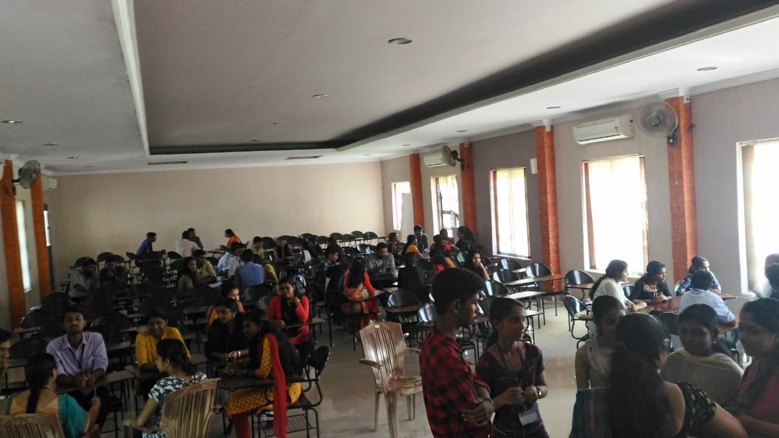
INDUCTION PROGRAMME COMMON FIRST INTERNAL
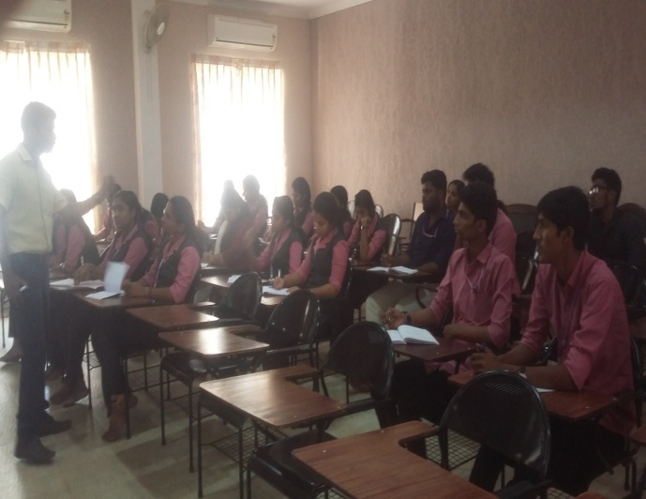
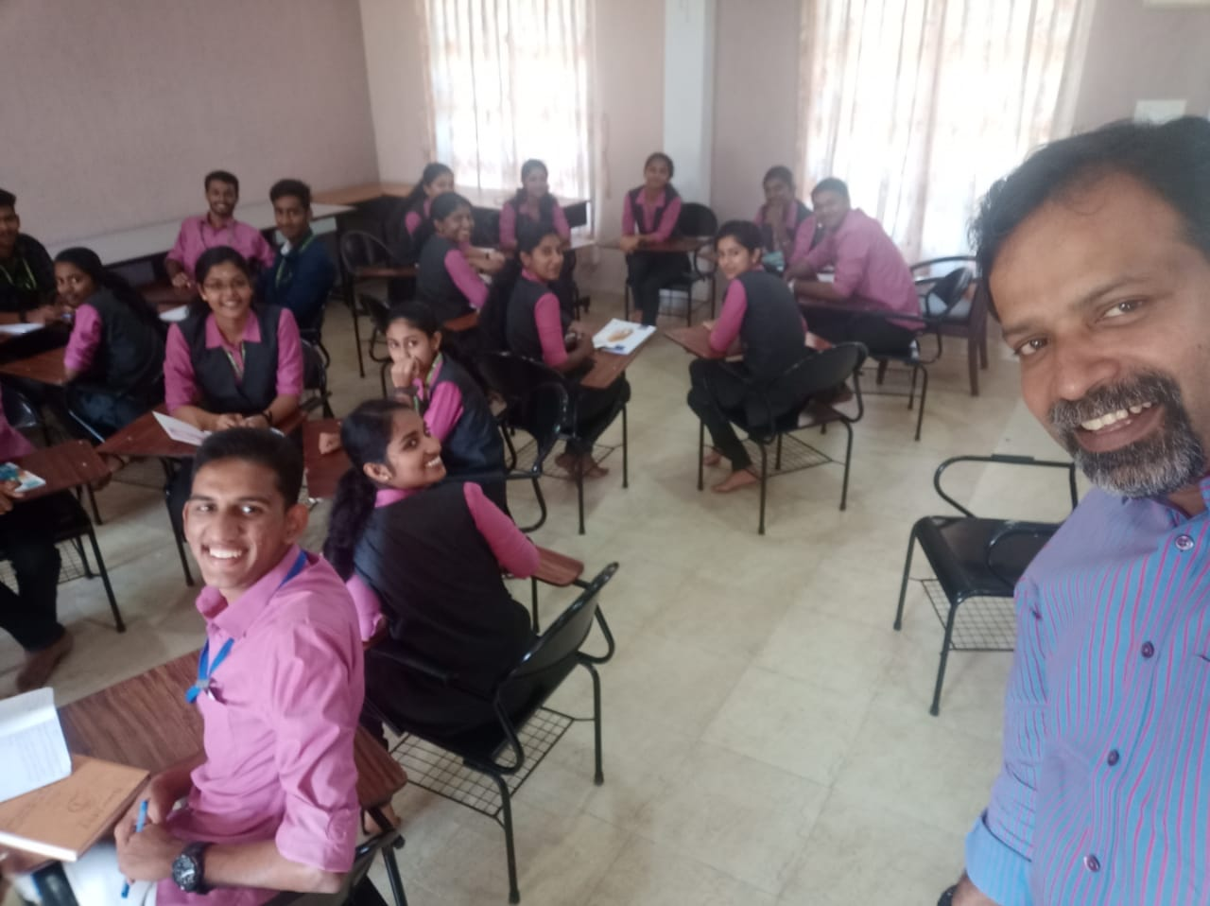 EXTERNAL.-MR.DOMINIC AV(2ND YEAR) EXTERNAL- MR.Madhu Mohan(first year)
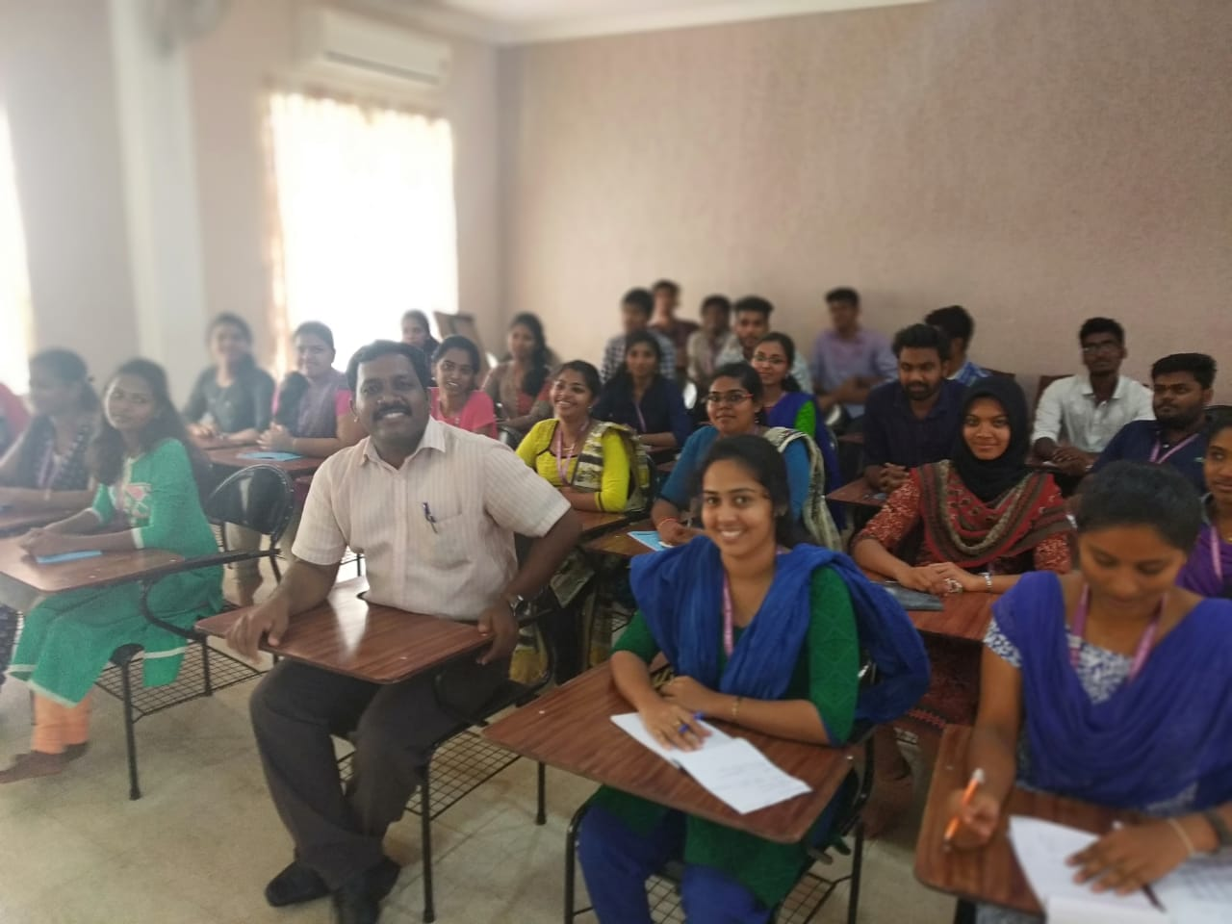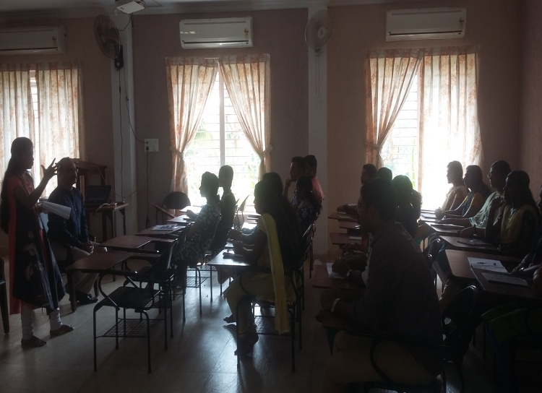
DR.SIBY KS(SECOND YEARS) DR.ABRAHAM STEPHEN (FIRST YEAR)
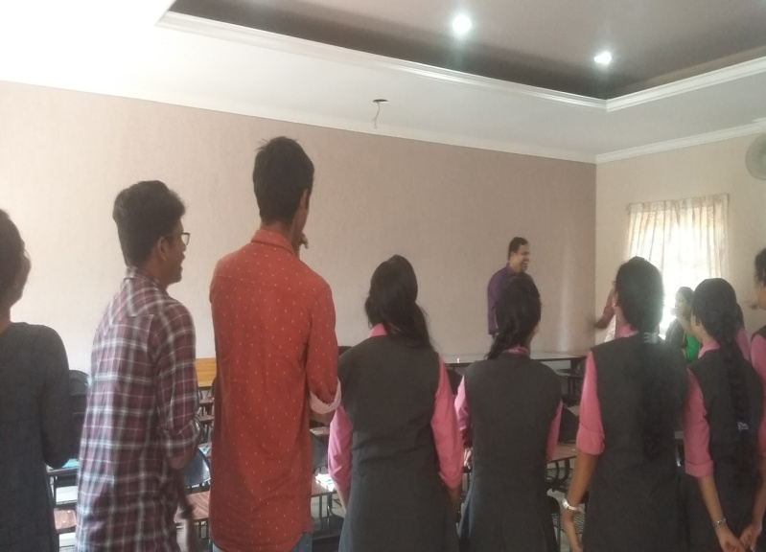
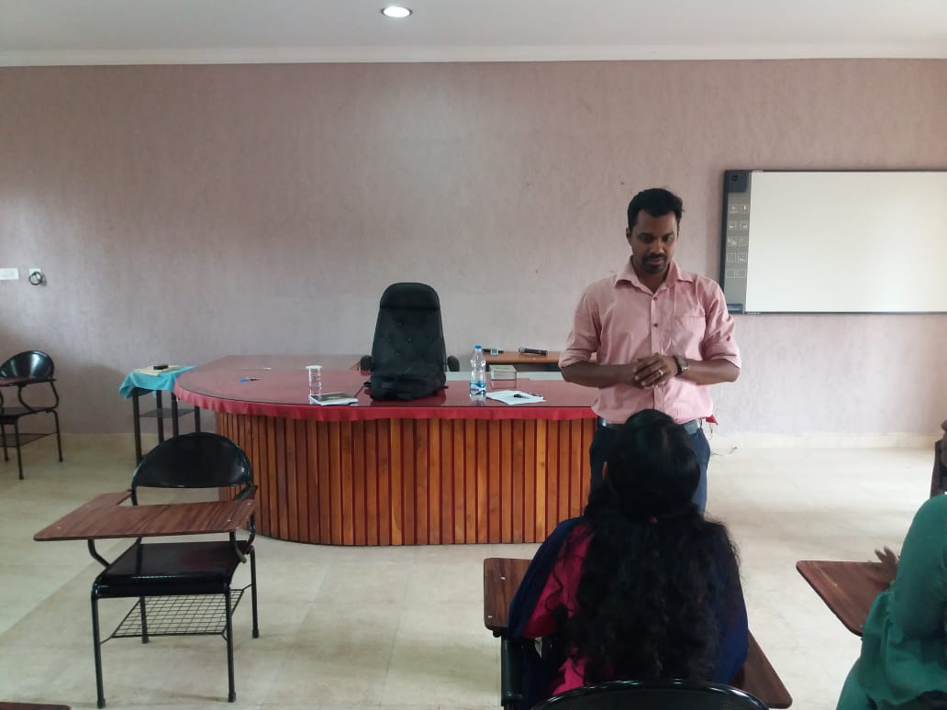
MR.Madhu Mohan(second years) Prof.joseph A J(First Year)

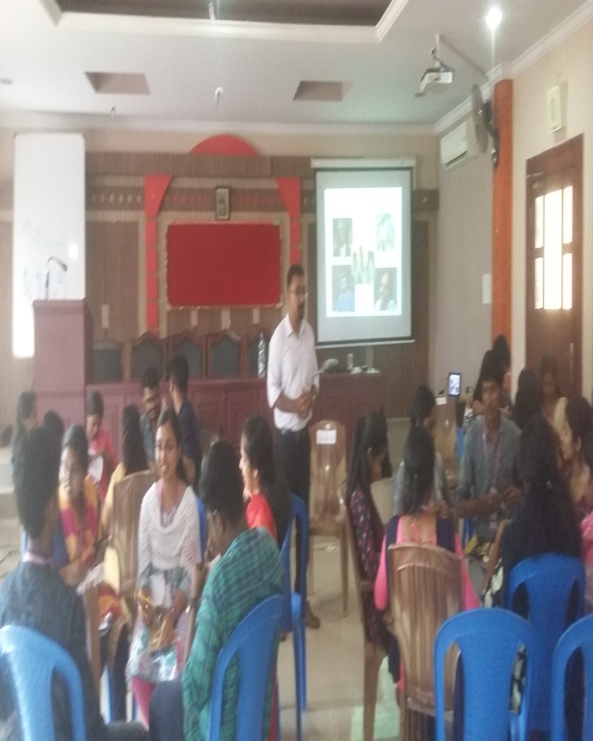
GROUP DISCUSION BY PROF.SANEESH PV(DD,MACFAST THIRUVALLA) AND INDUCTION PROGRAMME FOR FIRST YEAR STUDENTS BY DR SHIBU GEORGE,FORMER CORDINATOR,WWS,SAC EDATHUA
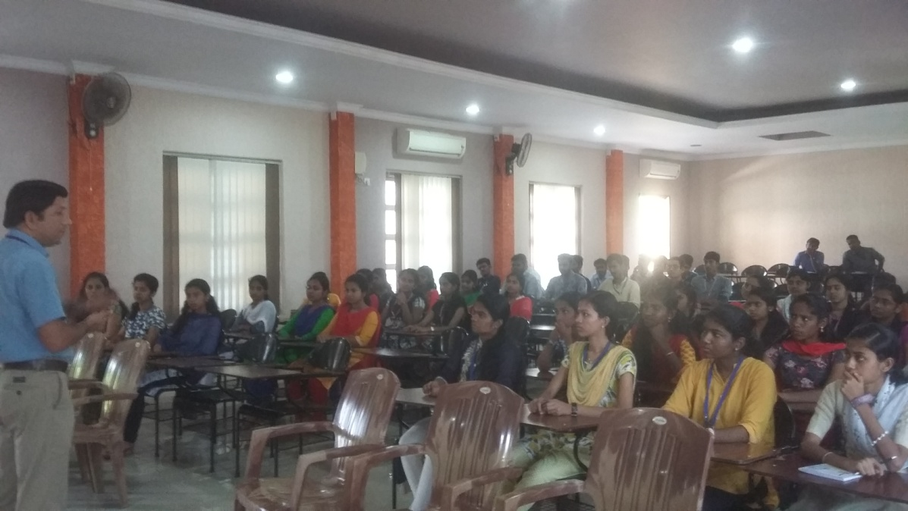
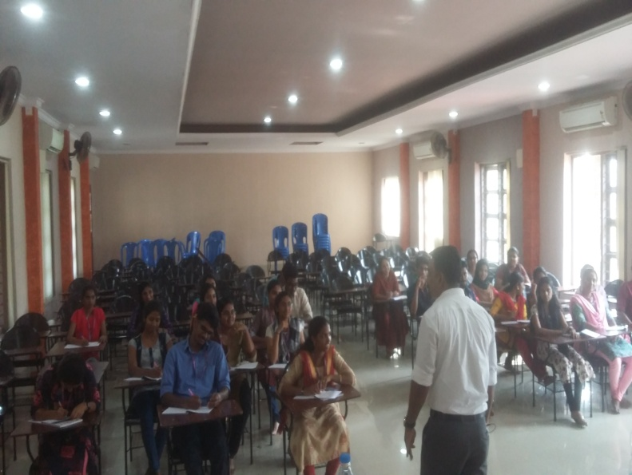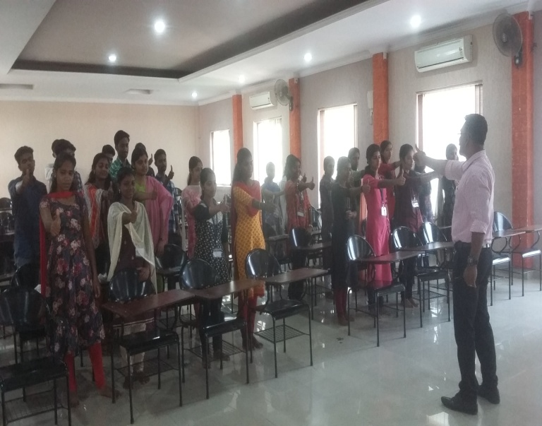

EXTERNAL MENTORING BY PROF. SANEESH PV, DEPUTY DIRECTOR MACFAST FOR FIRST AND SECOND YEARS
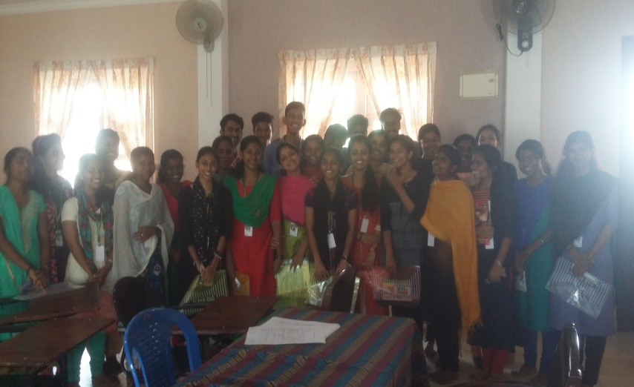
Group photo after distribuying files and other materials

