RESUME
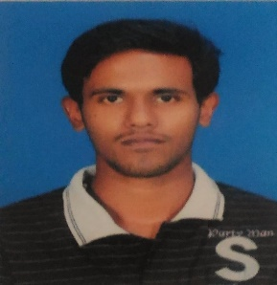
LIPSON LONAPPAN
THELLIYIL (H) E-mail:lipsonlonappan@gmail.com CHANGANKARY P.O phone:04772214067
EDATHUA mob:9447427846
Alappuzha Dist.
Kerala State
Pin: 689573

Career Objective
“I can work independently using my own initiative or as a part of a team”

Personal Profile
Sex : Male
Nationality : Indian
Date of birth : 05/04/1991
Height : 174cm
Language : English, Malayalam, Hindi
Religion : Christian SC RC

Educational Qualification
Degree/Course |  | Institution | University/Board | Year of Passing | % of Marks/CGPA
M.COM | Finance &taxation | St. Aloysius College, Edathua | Mahatma Gandhi | 2016 | 72.25/2.89
B.COM | Computer Application | St.Aloysius college, Edathua | Mahatma Gandhi | 2014 | 70%/2.79
PLUS TWO | Computer science | St.Aloysius,H.S.S, Edathua | Higher Secondary Examination | 2009 | 72%
S.S.L.C |  | St.Aloysius H.S.S,Edathua | Govt of kerala | 2007 | 60%

Certification
- Second price in quiz competition.
- Has passed the NET.

Project
- Customer preference between Pepsi and coca cola
- Customer perception towards internet banking.

Computer Proficiency
- Operating system : Windows XP, Vista, 7, 8 &10
- Packages : MS Word, Excel, PowerPoint, Tally 9.

Extra activities, skills & interests
- Administration & Management.
- Badminton, chess, swimming ,cricket, football
- Movies, internet surfing.

Declaration
I hereby declare that the above written particulars are true to the best of my knowledge and confidence.

(LIPSON LONAPPAN)

