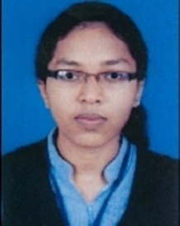

Name: Cibyna Thomas
Contacts: 8848274816
E mail: cibynacs2018@gmail.com
Designation Guest lecturer
Qualification MA
Teaching Experience 11 months
Research Experience NIL

Papers Presented
- Alterity and Female Body: An Analysis of the Representation of Devdasis as ‘Other’ in Textual Practices with Reference to Somdev’s “Story of Rupanika” and William Darlymple’s “Daughters of Yellamma” (Nine Lives). UGC Sponsored National Seminar Libertas 2K17 held at St. Mary’s College, Manarcaud on December 2017.

- “A Narrative on Football Fever: On Commodity Fetishism and the Aesthetics of Indian Football Aspirations.” UGC Sponsored International Seminar- “Marx Today” held at St. Berchmans College, Changanacherry on September 2018.

- “Fashion Subcultures and Countering Surveillance: The Paradox of Subculture becoming Cultural Mainstream in Fashion Industry.” UGC Sponsored International Conference on “Surveillance”held at Naippunya College, Cherthala (Kerala University) on December 2018.

Papers Published

- “Performance of the Liminal: A Critical Analysis of the Experience of Liminal with Reference to Chariot Festival in PerumalMurugan’sOne Part Woman.” IJHSSI Vol. 7 Issue 9 (2018): 46-51.

- “A Narrative on the Football Fever: On Commodity Fetishism and the Aesthetics of Indian Football Aspirations.” April. SB Academic Review. 2019. (Seminar Proceedings)

- “Nuances on the Experience of the Liminal: A Critical reading of the Idea of Limianl as Envisaged by Victor Turner.” Forthcoming Issue. JETIR. April. 2019.

Academic achievements andawardsIIIPosition in MA English

