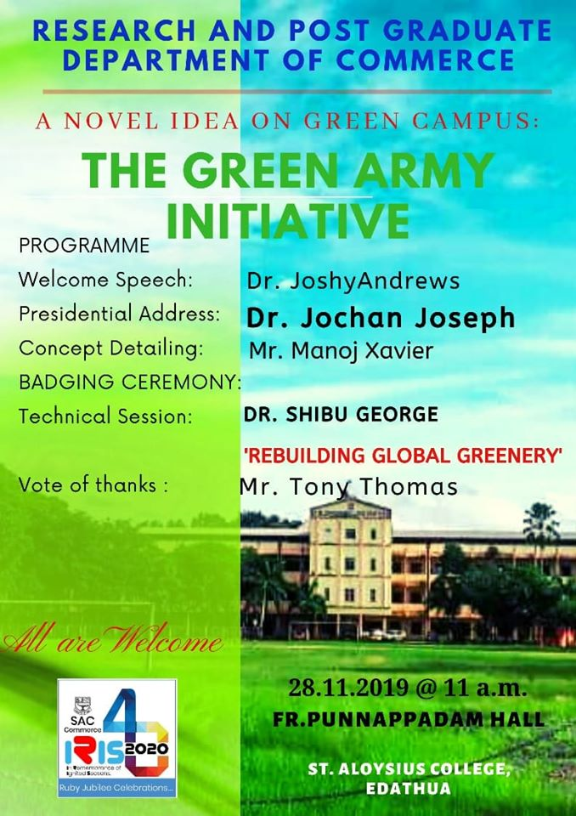
The Green Army was formed
St. Aloysius College Edathua, formed a 30 –member GREEN ARMY led by the Commerce Department on 28th November, 2019. The green army was formed with the aim of implementing a green protocol in college, a plastic free campus, and protecting the environment. At the meeting Dr. Shibu George took class about ‘REBUILDING GLOBAL GREENERY’. The meeting was chaired by College Principal Dr. Jochan Joseph. Dr. Joshy Andrews, Manoj Xavier and Tony Thomas spoke.
