REPORT ON NATIONAL SEMINAR
JANUARY 9 & 10, 2020
A two day National Seminar on ‘Dynamics of Derivatives’ was organised by Research and Post graduate Department of Commerce, St. Aloysius College, Edathua, in association with Mahatma Gandhi University, Kottayam. It intends to provide a platform to discuss and deliberate on the various dimensions of derivatives as a risk management tool as well as an investment opportunity. The deliberations will bridge the gap between industry and academia and develop an understanding of its relevance. The seminar will expose to the research scholars, young students of commerce and management, who are the potential leaders of the future, to provide ideas and practices that will equip them with relevant background to meet the emerging trends and practices across the globe.
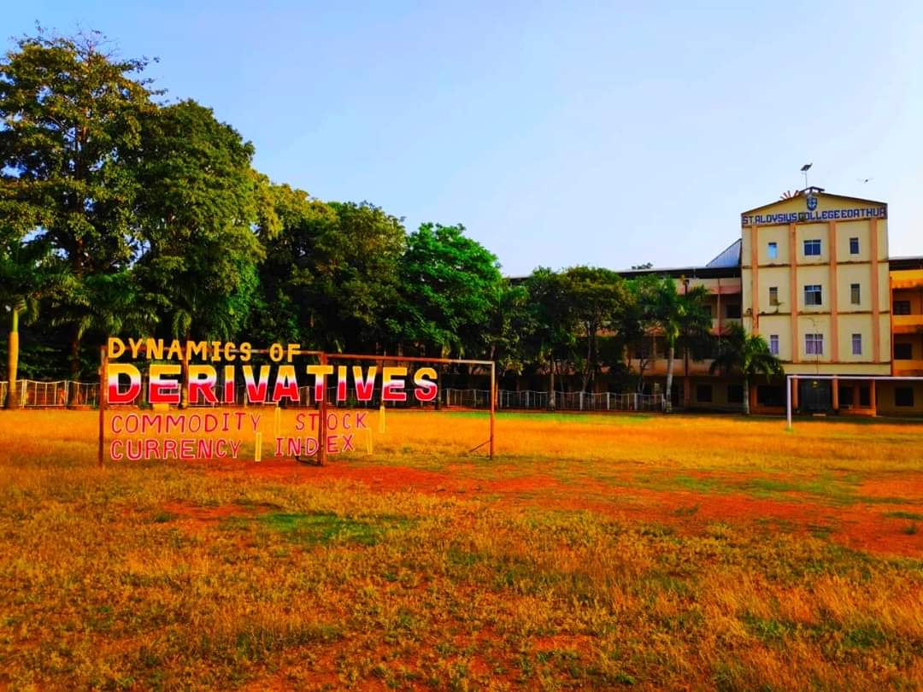
This seminar has been sponsored by SBI, Bank of Baroda, Canara Bank, LIC, IBS, TIA Kochi, Thakazhiyil Agencies, Flyover, Papa’s Family Mart and Kalagara Jewellery Mart. A total of 135 delegates from various institutions – Faculty and Professionals, Research scholars and students were participated in the seminar. The seminar started with the Inaugural programme graced by MCX – State Head, Mr. Biju Gopinathan along with the Manager of St. Aloysius College, Very Rev Fr Mathew Chooravady.
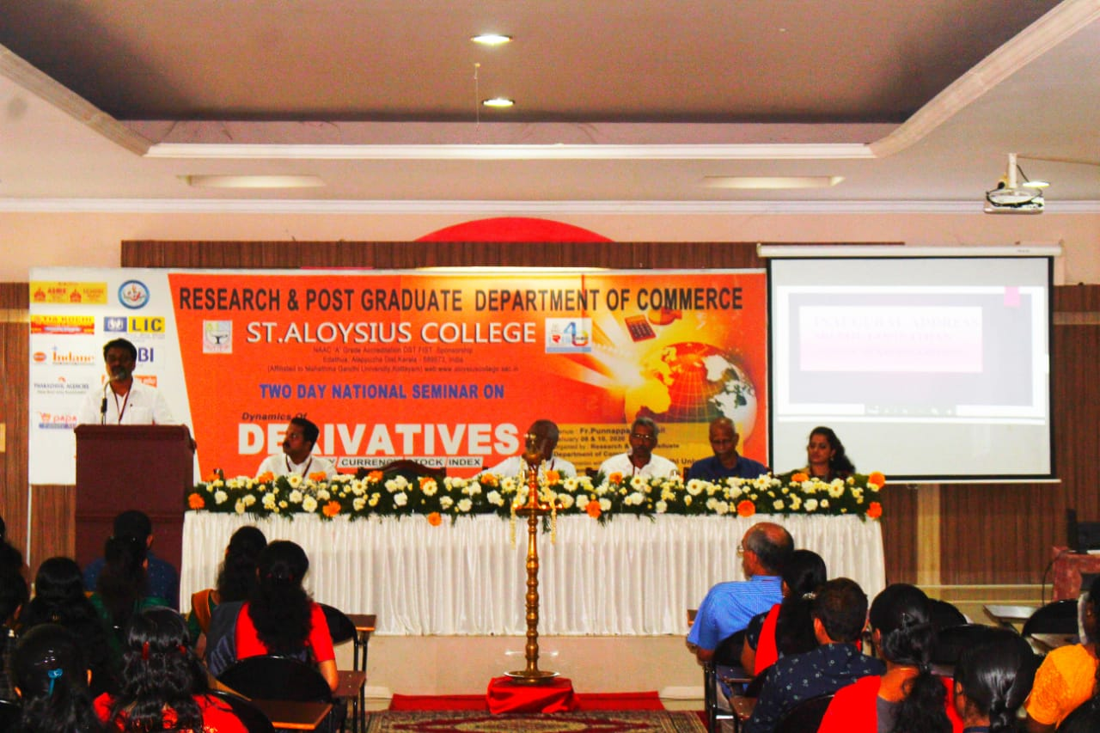
The session starts with Welcome address by The General convenor of the National Seminar 2019-20, Dr. Joshy Andrews, Assistant Professor and HOD of The Research and Post Graduate Department of Commerce. Then the Presidential Address by the Chairman of National Seminar 2019-20, Dr. Jochan Joseph, Principal. And the message was given by Very Rev Fr Mathew Chooravady, Manager. Then the programme was enlightened by lightening of lamp by the distinguished guests. The Inaugural speech was delivered by the Chief guest, Mr. Biju Gopinathan, State Head, MCX. Followed that Felicitation by Prof. Jerome P V, Coordinator- Bcom Computer Application. The Inaugural session ended with vote of thanks by the coordinator of the national seminar 2019-20, Prof. Stefy K Jose, Assistant Professor, The Research and Post Graduate Department of Commerce. 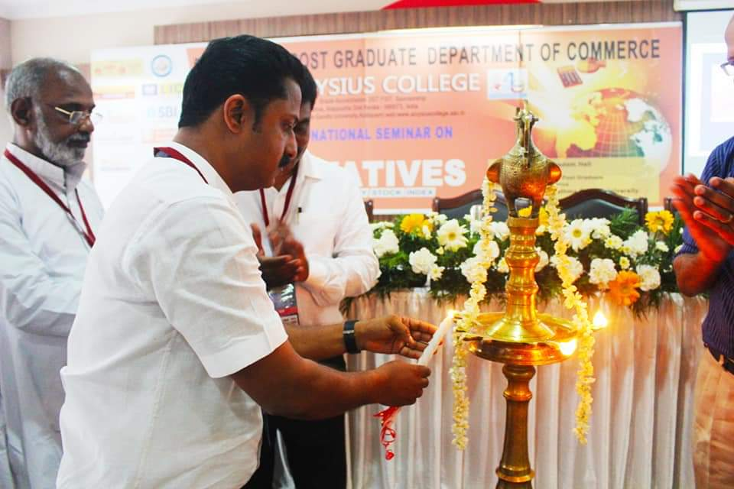
Following the inaugural session, there were two technical sessions. The session speakers were Dr. Tomy Mathew, HOD of Commerce (Rtd), CMS College Kottayam and Mr. Eldo Issac, Chief Manager- Commodity, Geojit Financial Services. Dr. Tomy Mathew delivered his talk on ‘Demystification of the concept: Derivatives’ and in the post lunch session, Mr. Eldo Issac delivered his talk on ‘Indian Commodity Futures Market – Prospects and Challenges.
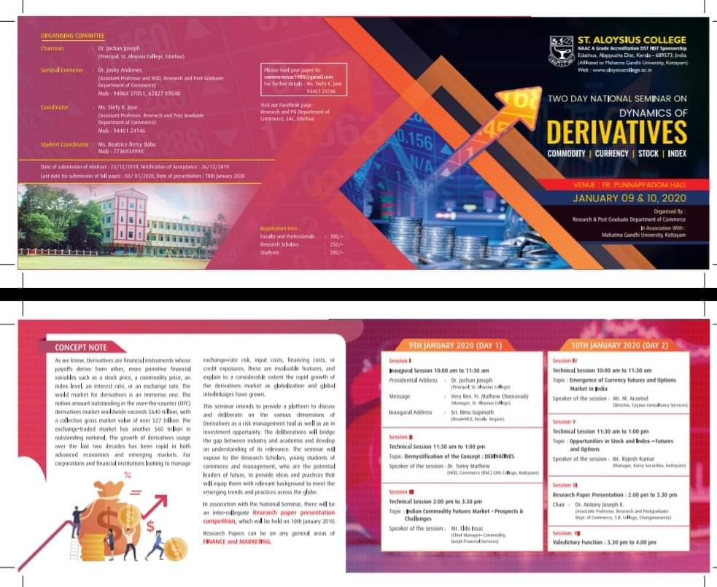
Second day of the seminar started with the third technical session. The session speakers were Mr. M Aravind – Director, Cygnus Consultancy Services and Mr. Praveen Pathiyil, Executive director, Pentad Securities. And the talk was on ‘Emergence of Currency Futures and Options Market in India.’ Following that fourth technical session started with an invited talk by Mr. Rajesh Kumar, Manager, KARVY Securities, Kottayam, on ‘Opportunities in Stock and Index – Futures and Options.’ And these four technical sessions were very interactive in nature. The speeches were followed by lot of queries, discussions and viewpoints of the participants and the speakers.
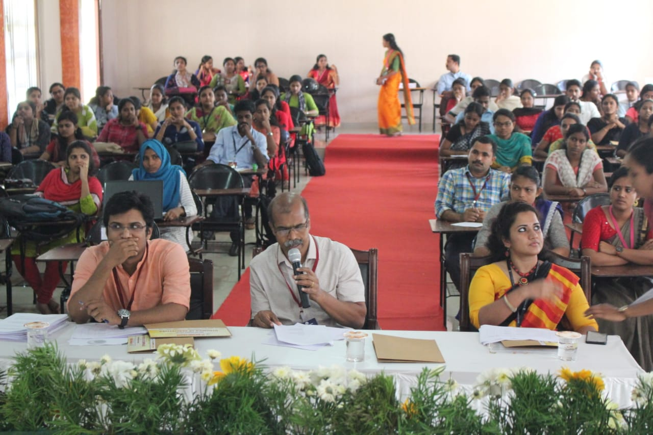
An inter-collegiate Research paper presentation competition was held in the post lunch session in association with the national seminar. Research papers were on any general areas of Finance and Marketing. And the session was chaired by Dr. Antony Joseph K, Associate Professor, Research and Post Graduate Department of Commerce, SB College Changanachery. This was followed by the Valedictory Function. The same started with the welcome speech by Prof Praveen Joseph, Assistant Professor, The Research and Post Graduate Department of Commerce. The Presidential address was given by Dr. Kochu Thresiamma Joseph, HOD, The Research and Post Graduate Department of Mathematics and she distributed the prizes and the certificates related with the seminar to the participants. Prof. Stefy K Jose, proposed vote of thanks.
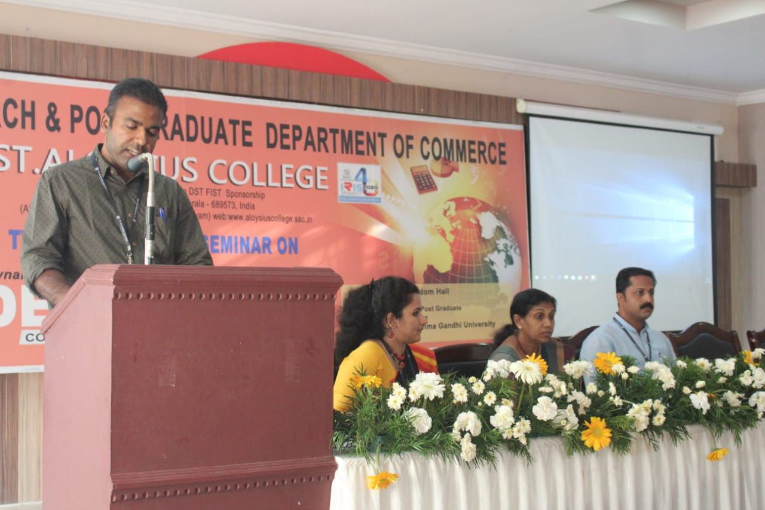
The entire programme was coordinated with the support of the Principal and Faculties of Research and Post graduate Department of Commerce, St. Aloysius College, Edathua. And a special mention to the PG students of the department, who lead a remarkable role to the success of the National seminar which is headed by the student coordinator of National seminar 2019-20, Ms. Beatrice Betcy Babu.

