DUST BINS DONATED
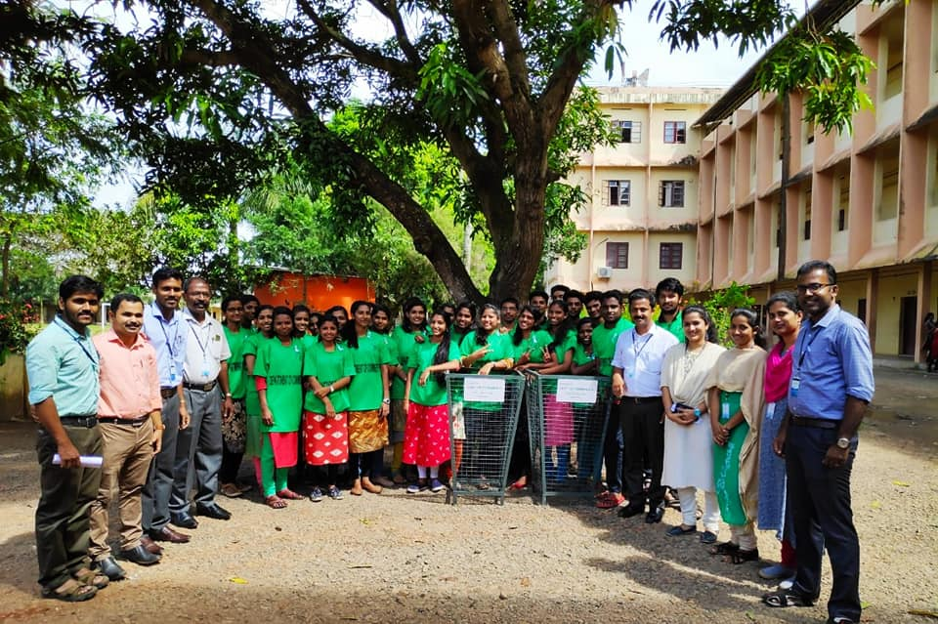
Green Army of Commerce Department donated dust bins to the College as part of clean campus and green campus initiative. 30 Green army volunteers cleaned the ground and premises of the college on 28th November 2019.

